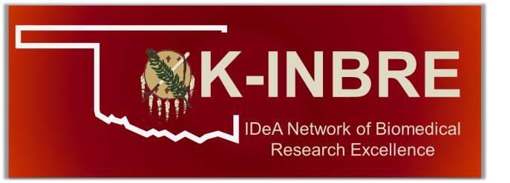
Curriculum Development Grant
OK-INBRE Network Community Colleges
FALL - SPRING – SUMMER
Funds for salary ($2,500) will be provided to assist faculty members at the OK-INBRE network Community Colleges in the preparation of curriculum redesign and course development intended to improve the preparation of future biomedical researchers.

This application may be downloaded at okinbre.ouhsc.edu.

Name: Institution:

E-mail:

Address:

Telephone:

Semester for which funds are requested:

Working Title for Curriculum Development:

Planned semester for implementation:

Include with this application:

- A description of the proposed curriculum development of a new or redesigned course and how this course will enhance the preparation of future biomedical researchers. Include a brief description of plans for implementing the new/redesigned course or curriculum and steps that have been or will be taken at your Institution. Proposals including the curriculum and career development plans should not exceed two pages and should be single spaced with one inch margins.

- NIH biosketch

Approved: Date: ____________
(Department Chair)

Approved: Date: ____________
(College Dean)

Send completed application to: Ms. Dawn Hammon at dhammon@osrhe.edu

Applications will be accepted throughout the year. There is no application deadline. For questions or additional information, please contact Dawn Hammon (dhammon@osrhe.edu).

Requirements for Curriculum Development Release Time Awards

1. Within 30 days of completing the award, the funded applicant must provide a progress report containing the syllabus and outline of the final course developed. It should also include when the new or revised course will go (or went) to the Institutional committee for approval and the committee’s decision on implementation of the newly designed or redesigned course. This report should be submitted to Dawn Hammon at dhammon@osrhe.edu.

2. If a progress report is not received within 30 days as required future requests for OK-INBRE funding will not be accepted.

ABOUT OK-INBRE

OK-INBRE is a statewide infrastructure research grant awarded by the National Institutes of Health (NIH) Institutional Development Award (IDeA) Program. The OK-INBRE Network is diverse, comprising OUHSC, the lead institution, whose primary mission is biomedical research, education, and patient care, along with eleven collaborating institutions. The OK-INBRE program helps to build State capacity for carrying out biomedical research by supporting promising new biomedical research faculty, recruiting students into biomedical research careers, and sustaining vital statewide core facilities. The scientific themes of OK-INBRE are multi-disciplinary, targeting the fields of Infectious Diseases, Cancer, and Developmental Biology. These thematic foci are closely linked with the strategic research plan of the lead biomedical research-intensive institution. Support for students through OK-INBRE is provided by summer internships, participation in the faculty research projects, and enrollment in new educational programs in bioinformatics. An integrated network of bioinformatics facilities is also supported that is dedicated to supporting research in big data analysis. The NIH IDeA program supporting OK-INBRE is funded by the National Institute of General Medical Sciences.

